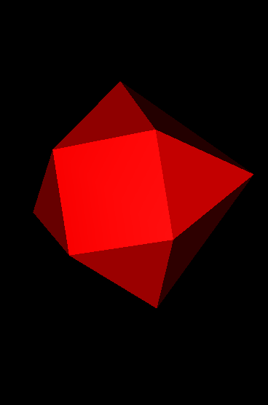

Lab 1 Report

Visualization Using Polygons

SSR3

Yuhan Zhang | CZ2003 Computer Graphics and Visualization | 29 September 2019

# Visualization Using Polygons: Graphic Modes

|  |  |
| --- | --- |
| **Mesh 1a** | **Notes** |
| The above polygon mesh is created with the following vertices:  -1.0 -1.0 1.0,  1.0 -1.0 1.0,  1.0 -1.0 -1.0,  -1.0 -1.0 -1.0,  0.0 1.0 0.0  The order of connection between the vertices are:  0, 3, 2, 1, -1,  0, 1, 4, -1,  1, 2, 4, -1,  2, 3, 4, -1,  3, 0, 4, -1,  The mesh is displaying using flat mode.  This corresponding document is named ‘polygons.wrl’. | Creating a polygon mesh in vrml requires a set of vertices with a specified order to connect them. The order of connection determines which surfaces to create and how the mesh will look like in bsContact. |
| **Mesh 1b** | **Notes** |
| The above polygon mesh is the same mesh as Mesh 1a, but with the wireframe connections only. | The wireframe options allow bsContact to show only the connections of vertices in which the polygon mesh is built on. |
| **Mesh 1c** | **Notes** |
| The above polygon mesh is the same mesh as Mesh 1a and 1b, but with only the vertices. | The vertices option allow bsContact to show only the vertices defined. This may be useful for planning or debugging the order of connections for the vertices. However, the display of the vertices are quite small and difficult to locate. |

Visualization Using Polygons: DiffuseColor

|  |  |  |
| --- | --- | --- |
| **Color 1a** | **Color 1b** | **Color 1c** |
| Above is Mesh 1a with diffuseColor set to 1 0 0. | Above is Mesh 1a with diffuseColor set to 0 1 0. | Above is Mesh 1a with diffuseColor set to 0 0 1. |
| **Notes** | | |
| The three values in the diffuseColor parameter defines the color of the mesh displayed. The first value corresponds to the amount of red, the second corresponds to the amount of green, and the third corresponds to the amount of blue. The values inputted into these parameters must be in the range of 0 to 1. | | |
| **Color 2a** | **Color 2b** | **Color 2c** |
| Above is Mesh 1a with diffuseColor set to 0 0 0. | Above is Mesh 1a with diffuseColor set to 1 1 1. | Above is Mesh 1a with diffuseColor set to 0.5 0.5 0.5. |
| **Notes** | | |
| For all three parameters, the closer they are to 0, the darker their color would be. On the other hand, the closer they are to 1, the lighter their color would be. By setting all three parameters to the same value, they generated mesh would be a shade of grey depending on how close the inputted value is compared to 0 and 1. | | |
| **Color 3a** | **Color 3b** | **Color 3c** |
| Above is Mesh 1a with diffuseColor set to -1 -1 -1. | Above is Mesh 1a with diffuseColor set to -1 0 2. | Above is Mesh 1a with diffuseColor set to 2 2 2. |
| **Notes** | | |
| If any of the parameters are less than 0 and the rest are also less than or equal to 0, the color of the mesh would default to black (0 0 0), as shown in Color 3a. If any of the parameters are more than 1 and the rest are also more than 1, the color of the mesh would default to white (1 1 1), as shown in Color 3c. However, if one parameter is less than 0 and one parameter is more than 1, the parameter less than 0 would be regarded as 0 and the parameter more than 1 would be regarded as 1, as shown in Color 3b. | | |

Visualization Using Polygons: Exploration

|  |  |  |
| --- | --- | --- |
| **Mesh 2a** | **Mesh 2b** | **Notes** |
| Above shows a polygon mesh of a cube created with the following vertices:  -1.0 -1.0 1.0,  1.0 -1.0 1.0,  1.0 -1.0 -1.0,  -1.0 -1.0 -1.0,  1.0 1.0 -1.0,  -1.0 1.0 -1.0,  1.0 1.0 1.0,  -1.0 1.0 1.0  The order of connections between the vertices are:  0, 7, 5, 3, -1,  1, 0, 3, 2, -1,  1, 6, 7, 0, -1,  7, 6, 4, 5, -1,  3, 5, 4, 2, -1,  4, 6, 1, 2, -1  This corresponding document is named ‘polygons_cube.wrl’. | Above shows a polygon with the same vertices as the mesh in Mesh 2a. However, the order of connections between the vertices are changed to:  3, 5, 7, 0, -1,  1, 0, 3, 2, -1,  1, 6, 7, 0, -1,  7, 6, 4, 5, -1,  3, 5, 4, 2, -1,  4, 6, 1, 2, -1 | The plane created from connecting the vertices will only be visible from the side the normal of the plane is pointing to, thus the order of connection of the vertices are crucial. This can be observed in Mesh 2a and Mesh 2b where the order of connections for one of the sides of the cube is reversed, thus causing that side to be invisible by looking from outside to cube. |
| **Mesh 3a** | **Mesh 3b** | **Notes** |
| Above shows the mesh of a hexagon created with the following vertices:  -1.0 1.0 2.0,  -1.0 -0.732 1.0,  -1.0 -0.732 -1.0,  -1.0 1.0 -2.0,  -1.0 2.732 -1.0  -1.0 2.732 1.0  The order of connections between vertices are:  0, 1, 2, 3, 4, 5, -1,  0, 5, 4, 3, 2, 1, -1  This corresponding document is named ‘polygons_hex.wrl’. | Above shows the mesh of a hexagon created with the same vertices as Mesh 3a. However, the order of connections between the vertices are changes to:  0, 1, 5, 2, 3, 4, -1,  0, 5, 4, 3, 2, 1, -1 | Please refer to notes for Mesh 2. Similarly, the order of connections between the vertices are crucial. As observed in Mesh 3b, the vertices are the same as Mesh 3a and all vertices were connected in some way. However, the order of connections were incorrect, resulting in a distorted shape instead of a regular hexagon as shown in Mesh 3a. |